1. What is a Computer Network?
A computer network is a group of two or more computers or devices connected together to share data, information, and resources. These devices communicate with each other through wired or wireless connections. A computer network helps users share files, printers, internet, and other services quickly and easily.
Key Points:
- Connects two or more computers.
- Shares data and resources.
- Uses wired or wireless connection.
- Makes communication fast and easy.

2. Discuss Various Types of Network Topologies
Network topology means the physical or logical arrangement of computers and cables in a network. It shows how devices are connected with each other.
The main types of network topologies are:
a) Bus Topology
In a bus topology, all computers are connected to one main cable called the backbone cable. Data travels through this cable to all devices.
b) Star Topology
In a star topology, every computer is connected to a central device such as a switch or hub. All communication passes through the central device.
c) Ring Topology
In a ring topology, each computer is connected to two neighboring computers, forming a circular path. Data moves around the ring until it reaches the destination.
d) Mesh Topology
In a mesh topology, every computer is directly connected to every other computer. This provides multiple paths for data transmission.
e) Tree Topology
A tree topology combines the features of star and bus topologies. It has a hierarchical structure with one main line and several branches.

3. Advantages and Disadvantages of Each Topology
Topology | Advantages | Disadvantages
Bus | Low cost, easy to install, uses less cable. | Backbone cable failure stops the whole network. Performance becomes slow with many devices.
Star | Easy to manage, easy to add devices, failure of one cable does not affect others. | If the central hub/switch fails, the whole network stops. Uses more cable.
Ring | Data flows in an orderly way. No data collision. | If one device or cable fails, the whole network may stop. Difficult to troubleshoot.
Mesh | Very reliable, multiple paths for data, high security. | Very expensive and difficult to install because many cables are needed.
Tree | Easy to expand, suitable for large networks, easy management. | Backbone failure affects many devices. Installation cost is higher.

4. What are the Applications of Computer Networks?
Computer networks are used to share information and resources between users and devices. They make communication faster, easier, and more efficient.
Applications of Computer Networks:
- File sharing between computers.
- Sharing printers, scanners, and other devices.
- Internet access.
- E-mail and instant messaging.
- Video and voice calls.
- Online learning (E-learning).
- Online banking and shopping.
- Business communication and data sharing.

5. What is OSI Model? Explain the Functions, Protocols and Services of Each Layer?
The OSI (Open Systems Interconnection) Model is a standard model used to explain how data moves from one computer to another through a network. It has 7 layers, and each layer performs a specific job.
Layer | Function | Example Protocols | Service
7. Application | Provides network services to users. | HTTP, FTP, SMTP, DNS | User communication
6. Presentation | Converts, encrypts and compresses data. | SSL, TLS | Data formatting
5. Session | Creates, manages and ends communication sessions. | NetBIOS, RPC | Session management
4. Transport | Delivers data reliably and controls errors. | TCP, UDP | End-to-end delivery
3. Network | Finds the best path and routes data. | IP, ICMP | Routing
2. Data Link | Sends data between two connected devices and detects errors. | Ethernet, PPP, HDLC | Frame delivery
1. Physical | Sends bits through cables or wireless media. | Ethernet, USB | Bit transmission
Easy way to remember:
Application → Presentation → Session → Transport → Network → Data Link → Physical

6. Explain the Following
I. LAN (Local Area Network)
A LAN is a network that connects computers within a small area, such as a room, office, school, or building. It provides high-speed communication and resource sharing.
Key Points:
- Covers a small area.
- High speed.
- Low cost.
- Example: School computer lab.

II. MAN (Metropolitan Area Network)
A MAN connects multiple LANs within a city or metropolitan area. It is larger than a LAN but smaller than a WAN.
Key Points:
- Covers a city.
- Connects many LANs.
- Medium speed.
- Example: A network connecting different university campuses in one city.

III. WAN (Wide Area Network)
A WAN connects computers over a very large area, such as different cities or countries. It is used to connect remote offices and users. The Internet is the largest example of a WAN.
Key Points:
- Covers a large area.
- Connects different cities or countries.
- Uses public or private communication links.
- Example: The Internet.

7. What are the network components? What do you mean by client-server network?
Answer
A computer network relies on several basic hardware and software parts to function properly. The primary network components include:
- Physical Media: Cables (Twisted pair, Fiber optic) or wireless signals (Wi-Fi) that carry data.
- Interconnecting Devices: Hardware like Hubs, Switches, and Routers that connect devices together.
- Computers/Nodes: Devices attached to the network, functioning as Clients or Servers.
- Software & Applications: Operating systems, protocols, and programs like web browsers and email clients.
A Client-Server Network is a network architecture where roles are divided between two types of computers. The Server is a powerful central computer that stays running $24/7$ to store data, manage resources, and provide services. The Client is a user's computer (like a laptop or phone) that requests services or files from the server. For example, when watching a video on YouTube, your phone acts as the client requesting data, and Google’s computer acts as the server.

8. Write some protocol names of each layer of TCP/IP model.
Answer
The TCP/IP model organizes communication protocols into four distinct layers. Each layer performs a specific role and uses dedicated protocols:
Layer Name PDF | Key Protocols Used PDF
1. Application Layer | HTTP, HTTPS, FTP, SMTP, DNS, DHCP
2. Transport Layer | TCP (Transmission Control Protocol), UDP (User Datagram Protocol)
3. Internet Layer | IP (IPv4, IPv6), ICMP, ARP, RARP
4. Network Access / Link Layer | Ethernet, PPP, HDLC, Wi-Fi (802.11)

9. Explain protocol, layer, peer and interface using layered diagram.
Answer
To simplify complex network communication, systems are structured using a layered model. Four fundamental terms define this architecture:
- Layer: A specific level in the network hierarchy that performs one dedicated task. Higher layers rely on the services provided by lower layers.
- Protocol: A strict set of rules that governs how two devices communicate with each other.
- Peer: Entities or processes that operate at the exact same layer on different devices. They communicate logically using a common protocol.
- Interface: The boundary between two adjacent layers on the same machine that defines what services the lower layer offers to the upper layer.
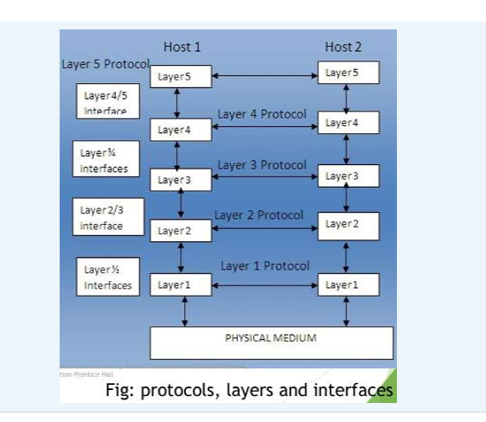
10. Explain connection multiplexing, connectionless and connection-oriented services.
Answer
Computer networks provide different modes of service to transfer data efficiently:
- Connection-Oriented Service: A dedicated connection is established first between the sender and receiver before any data transfer begins. Once communication ends, the connection is released. It provides reliable delivery.
  - Example: TCP protocol (similar to a phone call).
- Connectionless Service: Data packets are sent directly to the destination without setting up a connection beforehand. Each packet travels independently.
  - Example: UDP protocol (similar to sending a letter by post).
- Connection Multiplexing: The technique of combining multiple high-layer connections into a single lower-layer connection (Upward Multiplexing), or splitting one high-layer connection across multiple lower-layer connections (Downward Multiplexing) to optimize network resources.

11. Explain OSI and TCP/IP model
Answer
The OSI (Open Systems Interconnection) Model is a 7-layer theoretical framework developed by ISO to standardize network functions:
- Application Layer: User interface and network services (HTTP, FTP).
- Presentation Layer: Data formatting, encryption, and compression.
- Session Layer: Manages and synchronizes communication sessions.
- Transport Layer: Ensures end-to-end reliable delivery (TCP, UDP).
- Network Layer: Routing and logical IP addressing (IP, Router).
- Data Link Layer: Framing, MAC addressing, and error detection (Ethernet, Switch).
- Physical Layer: Bit transmission over physical media (Cables, Hub).
The TCP/IP Model is the practical 4-layer architecture used by the real-world Internet. It combines several OSI layers together:
TCP/IP Layer Name PDF | Equivalent OSI Layers PDF | Key Protocols PDF
1. Application Layer | Application, Presentation, Session (Layers 7, 6, 5) | HTTP, DNS, SMTP
2. Transport Layer | Transport (Layer 4) | TCP, UDP
3. Internet Layer | Network (Layer 3) | IP, ICMP, ARP
4. Network Access Layer | Data Link, Physical (Layers 2, 1) | Ethernet, Wi-Fi, PPP

12. Describe HDLC frame format.
Answer
HDLC (High-Level Data Link Control) is a bit-oriented Data Link Layer protocol that packages data into synchronous frames for transmission.
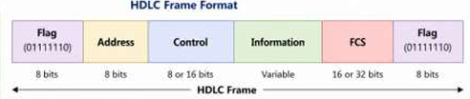
The HDLC frame consists of six fields:
- Start Flag (8 bits): Contains the fixed bit pattern 01111110 to mark the beginning of the frame.
- Address Field (8 or more bits): Identifies the destination station receiving the frame.
- Control Field (8 or 16 bits): Carries control info, sequence numbers, and acknowledgments for flow and error control.
- Information Field (Variable length): Carries the actual user data payload.
- FCS / Frame Check Sequence (16 or 32 bits): Contains CRC error-checking code to detect transmission errors.
- End Flag (8 bits): Same bit pattern 01111110 to mark the end of the frame.

13. How many types of HDLC frame there are? Explain control field formation of each of those.
Answer
There are three types of HDLC frames based on the structure and purpose of their Control Field:
- Information Frame (I-Frame):
  - Purpose: Used to transfer user data and piggybacked acknowledgments.
  - Control Field Structure: The first bit is always 0. It contains a 3-bit Sequence Number (SEQ) for the frame being sent, a 1-bit Poll/Final (P/F) bit, and a 3-bit Next Expected Frame Number (NEXT) for acknowledgment.
- Supervisory Frame (S-Frame):
  - Purpose: Used for flow and error control (carries no user data).
  - Control Field Structure: The first two bits are 10. It includes a 2-bit Type field (RR, REJ, RNR, SREJ), a P/F bit, and a 3-bit NEXT expected frame number.
- Unnumbered Frame (U-Frame):
  - Purpose: Used for link management, setting modes, and connectionless data transfer.
  - Control Field Structure: The first two bits are 11. It contains a P/F bit and 5 modifier bits to specify commands like DISC (Disconnect) or SABM (Set Asynchronous Balanced Mode).

14. When and why we use point –to-point connection?
Answer
A Point-to-Point Connection is a dedicated communication link established directly between two specific network devices or routers.
- When we use it:
  - When connecting two LAN networks over a long geographical distance (LAN-to-LAN connection via a leased line).
  - When a home user or remote user connects directly to an Internet Service Provider (ISP) using a dial-up modem or broadband connection.
- Why we use it:
  - Dedicated Bandwidth: The entire link bandwidth is reserved exclusively for communication between those two devices, ensuring fast and consistent speeds.
  - No Collisions: Since only two devices share the line, data signals never collide with other traffic.
  - Simplicity & Security: It does not require complex routing or multi-device addressing, making data transfer simple, private, and secure.
15. Draw the ppp frame format. Explain each field.
Answer
PPP (Point-to-Point Protocol) uses an HDLC-like frame format to deliver data over direct point-to-point links.
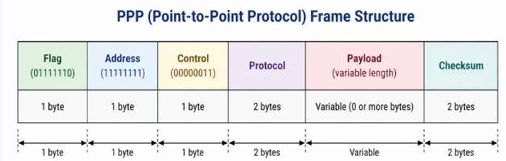
Field explanations:
- Flag (1 byte): Set to 01111110 to mark the beginning and end of the PPP frame.
- Address (1 byte): Always set to 11111111 (Broadcast) because point-to-point links do not require individual device addresses.
- Control (1 byte): Always set to 00000011 indicating Unnumbered Mode (no default sequence numbers or acknowledgments).
- Protocol (2 bytes): Identifies the type of data inside the payload. If it starts with bit 0, it carries network layer data (e.g., IP); if it starts with bit 1, it carries control messages (e.g., LCP or NCP).
- Payload (Variable): The actual user data or control data being transmitted (default up to 1500 bytes).
- Checksum (2 bytes): Used for error detection to ensure the frame arrived undamaged.

16. Explain the diagram for bring a line up and down in a PPP communication.
Answer
A PPP connection goes through six distinct sequential phases (states) from establishment to termination:
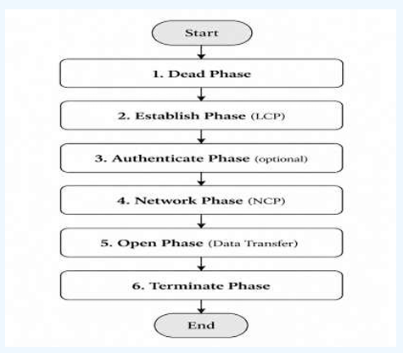
Explanation of phases:
- Dead Phase: The physical line is idle and no active connection exists.
- Establish Phase: LCP (Link Control Protocol) opens the connection and negotiates link configuration options.
- Authenticate Phase (Optional): Both sides verify each other's identity using authentication protocols (like PAP or CHAP).
- Network Phase: NCP (Network Control Protocol) configures network-layer parameters (such as IP address assignment).
- Open Phase: Data transfer takes place actively between the devices.
- Terminate Phase: LCP closes the connection, releases resources, and drops the line back to the Dead phase.

17. ATM has how many cell formats? Explain the commonly used one.
Answer
ATM (Asynchronous Transfer Mode) uses two cell formats depending on where the cell is transmitted:
- UNI (User-Network Interface): Used between a user device (like a computer) and the ATM switch.
- NNI (Network-Network Interface): Used between two ATM switches inside the network.
The most commonly used format is the UNI (User-Network Interface) format. An ATM cell has a fixed size of 53 bytes (5-byte header + 48-byte payload).
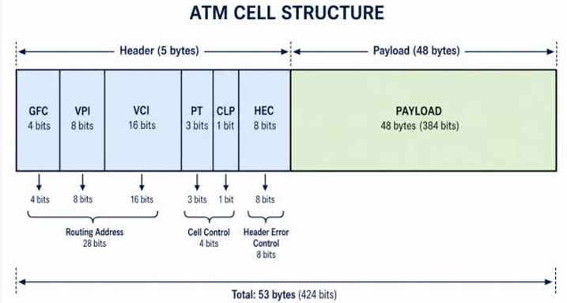
UNI Header Fields (Easy Explanation)
- GFC (Generic Flow Control - 4 bits): Controls the flow of data between the user and the network.
- VPI (Virtual Path Identifier - 8 bits): Identifies the virtual path that the ATM cell follows.
- VCI (Virtual Channel Identifier - 16 bits): Identifies the virtual channel inside the virtual path. VPI and VCI together help route the cell to the correct destination.
- PT (Payload Type - 3 bits): Indicates the type of data in the cell, such as user data or control/management data.
- CLP (Cell Loss Priority - 1 bit): Shows the priority of the cell. If CLP = 1, the cell has low priority and may be dropped during network congestion.
- HEC (Header Error Control - 8 bits): Checks the ATM header for errors and helps identify the start of each cell.

18. Why Standardization is necessary? Explain with example
Answer
Standardization is necessary to establish common rules, protocols, and hardware specifications across the telecommunication industry.
- Why it is necessary:
  - Interoperability: Ensures that equipment manufactured by different companies can communicate seamlessly.
  - Cost Reduction: Enables mass production of hardware, which lowers manufacturing costs and consumer prices.
  - Global Adoption: Encourages widespread adoption of new networking technologies.
- Example: Before network standards, if Company A made a computer and Company B made a router, they could not talk to each other because each used proprietary technologies. When the IEEE introduced standard protocols like IEEE 802.3 (Ethernet), devices from any manufacturer (e.g., HP, Dell, Cisco) could connect and communicate out of the box.
19. How does CSMA/CD work? Explain
Answer
CSMA/CD (Carrier Sense Multiple Access with Collision Detection) is a media access control method used in Ethernet (bus topology) to share a common communication cable.
How it works step-by-step:
- Carrier Sense (Listen): A station checks the physical cable to see if another device is transmitting.
- Multiple Access (Transmit): If the line is free, the station begins transmitting its data. If busy, it waits.
- Collision Detection (Detect): While transmitting, the station listens to the cable. If two stations transmit simultaneously, their signals collide.
- Jam Signal & Backoff (Recover): When a collision is detected, both stations stop transmitting immediately. Each station waits for a random period (backoff time) before trying to retransmit.
20. What do mean by token? Explain IEEE 802.4 and 802.5.
Answer
A Token is a special, small control frame that continuously circulates around a network. Only the station currently holding the free token is authorized to transmit data. This completely eliminates collisions.
- IEEE 802.4 (Token Bus):
  - Devices are physically connected in a bus topology, but the token is passed logically in a circle (ring) from node to node.
  - The node holding the token attaches data to it and sends it along the bus.
- IEEE 802.5 (Token Ring):
  - Devices are physically connected in a ring topology.
  - The token travels around the physical ring from one workstation to the next. Each device inspects or passes the token until it reaches its destination.
21. Why not just one big LAN?
Answer
Building a single, massive LAN for an entire organization creates severe performance and operational issues:
- Large Collision Domain: More connected devices lead to frequent collisions, forcing constant retransmissions and degrading speed.
- Shared Bandwidth Limits: All stations share the same physical cable capacity, reducing overall network performance.
- Cable Length Constraints: Physical standards (like Ethernet) have maximum cable length limits (e.g., 100 meters for UTP), making a single LAN impossible over long distances.
- High Delay & Congestion: Token-passing or broadcast networks slow down significantly when too many stations wait for turns or receive broadcast packets.

22. What devices are available for LAN's interconnection? Mention which layer they work.
Different networking devices are used to connect LANs or LAN segments. Each device works at a different OSI layer.
Device | OSI Layer | Data Handled
Repeater / Hub | Layer 1 (Physical) | Bits / Electrical Signals
Bridge / Switch | Layer 2 (Data Link) | Frames (MAC Address)
Router | Layer 3 (Network) | Packets (IP Address)
Application Gateway | Layer 7 (Application) | Application Data

23. Explain Hub and Bridge. Compare Them.
Hub
A Hub is a Layer 1 (Physical Layer) device. It connects multiple computers in a network. When it receives data from one computer, it sends the data to all other ports. It does not check any address.
Bridge
A Bridge is a Layer 2 (Data Link Layer) device. It connects two or more LAN segments. It checks the MAC address and sends data only to the correct destination.
Comparison
Feature | Hub | Bridge
OSI Layer | Layer 1 | Layer 2
Forwarding | Sends to all ports | Sends only to the correct port
Address Check | No | Yes (MAC Address)
Collision Domain | One collision domain | Separate collision domain for each port
Device Type | Simple (Dumb) | Intelligent (Smart)

24. Give a Bridge Learning Example.
A bridge learns the MAC address of devices automatically. This is called self-learning.
Step 1: C sends data to D
- Host C sends a frame to D.
- The bridge does not know where D is.
- So, it floods the frame to all ports.
- At the same time, it learns:
  - C → Port 1
Step 2: D replies to C
- Host D sends a reply.
- The bridge sees the frame comes from Port 2.
- It learns:
  - D → Port 2
Step 3: Future Communication
- Now the bridge knows both devices.
- It sends frames directly between Port 1 and Port 2.
- No flooding is needed.
Filtering Table
MAC Address | Port
C | Port 1
D | Port 2

25. What will happen if there is a loop between two nodes?
If there is a loop between two LAN segments, the network faces several problems.
Problems:
- Broadcast Storm: Broadcast frames keep circulating, using all network bandwidth.
- Frame Duplication: The same frame is copied and delivered many times.
- MAC Table Instability: The bridge keeps changing MAC address entries, causing incorrect forwarding.
As a result, the network becomes slow or may stop working.

26. What is Spanning Tree? How does it help Bridge?
Spanning Tree Protocol (STP) is a Layer 2 protocol (IEEE 802.1D). It creates a loop-free network by blocking extra paths.
How STP Helps a Bridge
- Removes loops by blocking unnecessary links.
- Prevents broadcast storms.
- Prevents frame duplication.
- Keeps the MAC table stable.
- If the main link fails, it automatically activates the backup link to keep the network running.

27. Compare and contrast between routers and bridge.
Answer
Bridges and Routers both forward network traffic, but they operate at different layers of the OSI model.
Similarities:
- Both are store-and-forward devices used to connect networks or network segments together.
Differences (Comparison Table):
Feature PDF | Bridge PDF | Router PDF
OSI Layer | Layer 2 (Data Link Layer) | Layer 3 (Network Layer)
Addressing Used | Hardware MAC Address | Logical IP Address
Forwarding Table | Filtering / MAC Table | Routing Table
Broadcast Protection | Forwards all broadcasts (No protection) | Blocks broadcasts (Provides firewall/isolation)
Loop Prevention | Spanning Tree Protocol (STP) | TTL (Time to Live) counter & Routing Algorithms
Best For | Small networks (up to ~200 hosts) | Large networks (thousands of hosts)
28. What do you mean by cut-through switching?
Answer
Cut-Through Switching is an advanced frame-forwarding technique used by network switches.
- Instead of waiting for the entire data frame to arrive in memory (Store-and-Forward), the switch reads only the first few bytes containing the destination MAC address and immediately begins forwarding the frame to the target port.
- Key Advantage: It significantly reduces end-to-end delay (latency).
- Use Case: Ideal for real-time applications requiring extremely low latency.
Plaintext
[ Read Destination MAC Address (First 6 Bytes) ] ---> [ Immediately Forward Frame ]
29. Compare and contrast between switch and bridge.
Answer
Switches and bridges are fundamentally similar as both make forwarding decisions based on Layer 2 MAC addresses, but they differ in scale and operation.
Similarities:
- Both operate at Layer 2 (Data Link Layer).
- Both use MAC addresses for forwarding and isolate collision domains per port.
Differences (Comparison Table):
Feature PDF | Bridge PDF | Switch PDF
Primary Purpose | Connects whole LAN segments | Connects individual host computers
Number of Ports | Few ports (typically 4 to 8) | Many ports (12, 24, 48+ ports)
Simultaneous Links | Limited parallel transmission | Supports multiple simultaneous connections
Hardware | Software-based processing | Hardware/ASIC-based fast processing
Buffer Memory | Per line card | Dedicated buffer space per port
30. What is FDDI? How does it work?
Answer
FDDI (Fiber Distributed Data Interface) is a high-speed LAN standard that transmits data over optical fiber cables at 100 Mbps across distances up to 200 kilometers.
How it works:
- Dual Ring Architecture: It uses two counter-rotating fiber rings — a Primary Ring for active data transmission and a Secondary Ring for backup.
- Timed Token Passing: A special token frame circulates around the ring. Only the station holding the token can transmit data.
- Self-Healing / Fault Tolerance: If a cable breaks or a device fails, the primary and secondary rings wrap around automatically to form a single working ring.

31. What are the advantages of FDDI?
Answer
The key advantages of FDDI include:
- High Speed & Throughput: Provides 100 Mbps transmission speed (and up to 200 Mbps if both rings are used simultaneously).
- High Fault Tolerance: The dual-ring structure automatically reroutes traffic if a fiber cable snaps or a station fails.
- Long Distance Coverage: Can extend up to 200 km, supporting thousands of users across large campus networks or MANs.
- Large Frame Size: Supports a maximum frame size of 4,352 bytes (much larger than Ethernet’s 1,500 bytes), allowing better data transfer efficiency.
- No Collisions: Token passing guarantees orderly access without packet collisions.
32. Draw the FDDI frame formation.
Answer
An FDDI Frame consists of the following sequential fields:
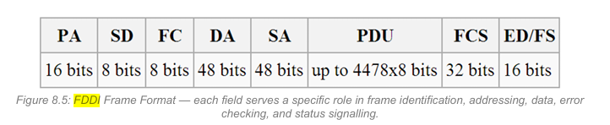 Field Explanations:
- PA (Preamble - 16 bits): Synchronizes the receiver with incoming signals.
- SD (Start Delimiter - 8 bits): Marks the beginning of the frame.
- FC (Frame Control - 8 bits): Identifies the frame type (data or token).
- DA (Destination Address - 48 bits): MAC address of the target recipient.
- SA (Source Address - 48 bits): MAC address of the sender.
- PDU (Protocol Data Unit): The actual user data payload being carried.
- FCS (Frame Check Sequence - 32 bits): CRC checksum for error detection.
- ED/FS (End Delimiter / Frame Status - 16 bits): Marks frame termination and indicates if the frame was received/copied correctly.

33. Differentiate between Ethernet and token ring.
Answer
Ethernet and Token Ring are two different media access control methods used in local area networks.
Feature PDF | Ethernet (CSMA/CD) PDF | Token Ring (Token Passing) PDF
IEEE Standard | IEEE 802.3 | IEEE 802.5
Topology | Bus / Star | Ring
Access Method | Contention-based (CSMA/CD) | Token Passing
Collisions | Yes, collisions can occur and are detected | No collisions (only token holder transmits)
Low Traffic Performance | Excellent (Fast, no waiting time) | Good (slight overhead from token passing)
High Traffic Performance | Degrades sharply due to collisions | Excellent and predictable (No collisions)

34. If there is a network like 172.168.0.0/17, then determine the followings:
Initial Information:
- Given Network: 172.168.0.0/17 (Class B Network)
- Default Class B Prefix = /16
- Default Host Bits = $32-16=16$ bits
a. How many subnets are possible?
- Borrowed Subnet Bits ($n$) = $17-16=1$ bit
- Possible Subnets = $2^{n}=2^{1}=2\text{ subnets}$
b. How many hosts are there?
- Remaining Host Bits ($h$) = $32-17=15$ bits
- Total Hosts per subnet = $2^{15}=32,768$
- Usable Hosts per subnet = $2^{15}-2=32,766\text{ hosts}$
c. What is the subnet mask of the network?
- Binary Mask: 11111111.11111111.10000000.00000000
- Dotted Decimal Subnet Mask = $255.255.128.0$
d. In the 1st subnet, what are the IP addresses of network address, 1st host address, last host address and broadcast address?
- Network Address: 172.168.0.0
- 1st Host Address: 172.168.0.1
- Last Host Address: 172.168.127.254
- Broadcast Address: 172.168.127.255
e. In the 18st subnet, what are the IP addresses of network address, 1st host address, last host address and broadcast address?
- Answer: Since the prefix /17 borrows only $1$ bit ($2^{1}=2$), only 2 subnets are possible in total (172.168.0.0/17 and 172.168.128.0/17). Therefore, an 18th subnet does not exist for this prefix.

35 & 37. Physical media available for Ethernet, Fast Ethernet, and Gigabit Ethernet and their maximum segment length.
Answer
The physical media types and maximum segment lengths for Ethernet standards are summarized below:
1. Classic Ethernet (10 Mbps):
- 10BASE5: Thick Coaxial Cable | Max Length = 500 m
- 10BASE2: Thin Coaxial Cable | Max Length = 185 m
- 10BASE-T: UTP Cat 3/5 Copper Cable | Max Length = 100 m
- 10BASE-FL: Optical Fiber | Max Length = 2,000 m
2. Fast Ethernet (100 Mbps):
- 100BASE-TX: UTP Cat 5e Copper Cable | Max Length = 100 m
- 100BASE-T4: UTP Cat 3 Copper Cable (4 pairs) | Max Length = 100 m
- 100BASE-FX: Multimode Fiber = 2,000 m (Full Duplex) / Singlemode Fiber = 20 km
3. Gigabit Ethernet (1000 Mbps / 1 Gbps):
- 1000BASE-T: UTP Cat 5e/6 Copper Cable | Max Length = 100 m
- 1000BASE-SX: Short Wavelength Multimode Fiber | Max Length = 275 m
- 1000BASE-LX: Long Wavelength Fiber (Singlemode) | Max Length = 5,000 m (5 km)
- 1000BASE-LH: Long Haul Singlemode Fiber | Max Length = 80 km
- 1000BASE-CX: Shielded Copper Twinax | Max Length = 25 m
36. What leads to fast Ethernet?
Answer
Classic Ethernet running at 10 Mbps became too slow as file sizes increased and more computers joined local networks. This demand for higher speed led to the development of Fast Ethernet:
- Failure of Early Competitors: Early high-speed optical ring technologies like FDDI and Fiber Channel failed to become popular for desktop systems due to complex management, expensive hardware chips, and high deployment costs.
- Reuse of CSMA/CD & Frame Format: Instead of inventing a completely new protocol, engineers upgraded Ethernet to 100 Mbps while retaining the simple, cheap, and familiar CSMA/CD access protocol and existing Ethernet frame format.
- Smooth Upgrade Path: Keeping the same software interface allowed organizations to upgrade network speeds easily without replacing their entire existing infrastructure.

